Surgery name
Surgery contact details
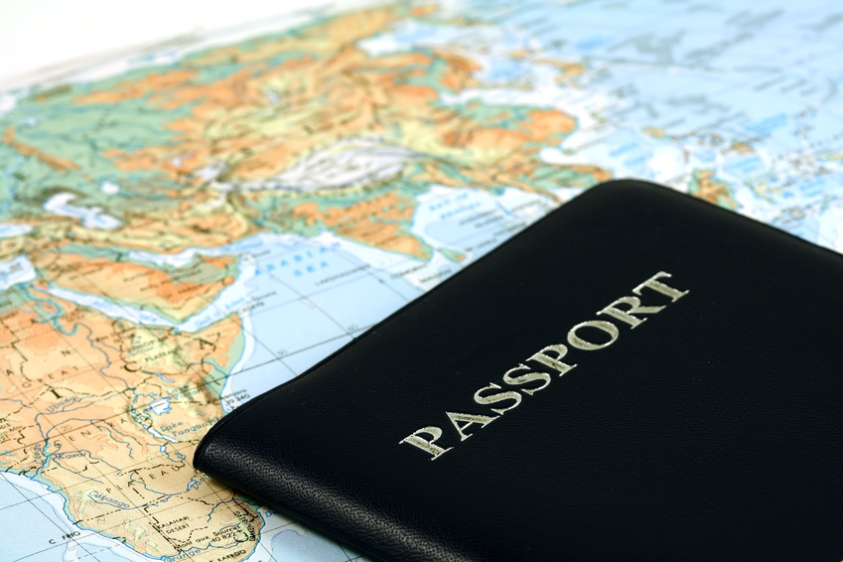

Thank you for attending your appointment today. Whilst you haven’t come along for advice concerning a trip abroad, are you planning to travel in the future, perhaps to visit friends and relatives or to return to the homeland of your origin?
Here is some very important advice for you
- Research has shown that this type of travel puts you at greater risk of acquiring travel related infection such as enteric fever (including typhoid) and of malaria
- It is really important that you visit the surgery before you travel to seek advice and protection for your trip
- We are really busy at the surgery and so it is essential that you try to book your appointment with the travel nurse well in advance of your departure date – about 6-8 weeks before you travel is ideal. We ask you to try to remember this, as it is so important to get protected.
- Occasionally, you will have some urgent reason that means you cannot plan in advance and in these circumstances, we will do our best to help. It is never too late to get some protection, even up to the day of your departure, so please seek advice
- If you use the internet, a good places to look for information is http://www.nhs.uk/Livewell/TravelHealth/Pages/Travelhealthhome.aspx

We look forward to seeing you in the future for your travel appointment.

